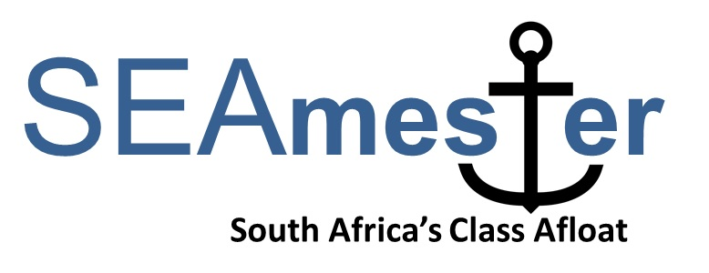

Lecturer support for the SEAmester programme
APPLICATION FORM - Deadline Friday 5th April 2019
To be returned to Isabelle.Ansorge@uct.ac.za as a single PDF form

Personal details

Title
First name
Last name
Gender | - Male  - Female
Date of birth
Contact Number
Email Address
Country of citizenship
Passport number
ATTACH SCAN TO THIS FORM IF AVAILABLE – NB: PASSPORT DETAILS CAN BE PROVIDED LATER IF YOU DO NOT HAVE.
Expiry Date
South African ID (if available)
Email
Institute
Department
Field of Research/Expertise
Clothing size | - S  - M  - L  - XL  - XXL  - XXXL
Name of contact person in case of any emergency
Airport – PLEASE TICK THE CLOSEST AIRPORT TO YOU. | - PORT ELIZABETH  - EAST LONDON  - DURBAN  - O TAMBO - JOHANNESBURG
Address
Email
Telephone/Mobile number
Short Biography and Photo

Information on Lectures and their relevant practical sessions.

PLEASE NOTE that all lectures must include a practical component that allows students to gain hands on experience

i.e. a lecture on benthic ecosystems might plan for students to sort through various sediments i.e. mud, shell, sand etc.. Equipment that could be requested for this could be benthic grab, laboratory samples of different sediment, microscopes, petri dishes, tweezers etc..

PLEASE NOTE: STUDENTS RANGE FROM HONOURS TO PHD AND ACROSS ALL UNIVERSITIES. SOME HAVE BEEN EXPOSED TO OCEANOGRAPHY/MARINE BIOLOGY OTHERS ARE RELATIVELY NEW TO THE SUBJECT – PLEASE CONSIDER THIS WHEN WRITING UP YOUR LECTURES.

Please provide a title for each lecture that you plan to give

EACH LECTURE IS 50 MIN AND YOU SHOULD PLAN FOR A MAX 4 LECTURES.

Please provide information on the practical linked to the lecture i.e. all lectures must have a practical component that will be completed by the students during their deck training.

What equipment will you be providing for your practical sessions

What equipment is required.
IN ADDITION:

SEAmester students will work in groups of 4 with a lecturer/mentor on a single project throughout the cruise.

In this box please provide a title for a suitable project that links into both the deck and class work that you will have given.

